Title | Discrete Correlation
Aim | To study mathematical operation Correlation and measure degree of similarity between two signals
Objective | 1. Write a function to find correlation operation.  2. Calculate correlation of a DT signals and verify the results using mathematical formulation.
Input Specifications | 1. Length of first Signal L and signal values.  2. Length of second Signal M and signal values.
Problem Definition | 1. Find auto correlation of input signal. What is the significance of value of output signal value  at n=0 ?.  2. Find auto correlation of delayed input signal.  3. Find cross correlation of input signal and delayed input signal,  4. Find cross correlation of input signal and scaled delayed input signal.  5. Compare the resultant signals. Give your conclusion.
Program | Correlation.py  x1=[1,2,3,4]  x2=[5,6,7,8]  x2=[0 for i in range(len(x1)-1)]+x2+[0 for i in range(len(x1)-1)]  c=-(len(x1)-1)  ol=[]  while len(x2)>=len(x1):  temp=x2[-len(x1):]  y=0  for i,j in zip(temp,x1):  y+=(i*j)  print(f"{i}*{j}",end=" + ")  print(f" = {y}")  c+=1  ol.append(y)  x2.pop()  print(ol)  autocorrelation.py  x1=[1,2,3,4]  x2=x1.copy()  x2=[0 for i in range(len(x1)-1)]+x2+[0 for i in range(len(x1)-1)]  c=-(len(x1)-1)  ol=[]  while len(x2)>=len(x1):  temp=x2[-len(x1):]  y=0  for i,j in zip(temp,x1):  y+=(i*j)  print(f"{i}*{j}",end=" + ")  print(f" = {y}")  c+=1  ol.append(y)  x2.pop()  print(ol)  correlation with delayed signal  x1=[0,1,-2,3,-4]  x2=[0.5,1,2,1,0.5]  sx=0  sy=2  x2=[0 for i in range(len(x1)-1)]+x2+[0 for i in range(len(x1)-1)]  c=-(len(x1)-1)  ol=[]  while len(x2)>=len(x1):  temp=x2[-len(x1):]  y=0  for i,j in zip(temp,x1):  y+=(i*j)  c+=1  ol.append(y)  x2.pop()  print(ol)  print("zeroth positon is at index "+str(sx+sy))
Output | Autocorrelation.py  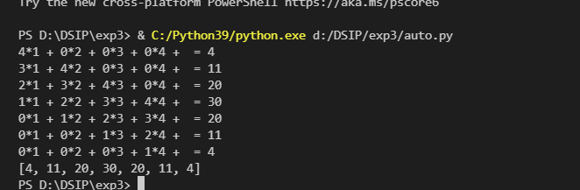  Correlation.py  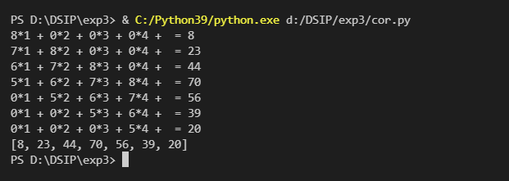  Correlation with delayed signal  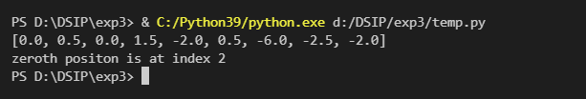
Outcome | We have successfully implement cross corelation , autocorrelation and correlation with delayed signal.  The delayed signal appears left shifted as compared to the one without delayed input. Autocorrelation is the correlation of the signal with itself

